Your Name
Supervisor Name
Course Name
Due Date

Title of Your Paper
Lorem ipsum dolor sit amet, consectetur adipiscing elit. In nec risus pretium, condimentum leo imperdiet, iaculis lacus (Author 14). Curabitur volutpat sagittis facilisis. Aliquam eget magna pharetra, venenatis metus vel, volutpat nunc. In feugiat ligula quis tellus consectetur malesuada vel et risus. Etiam tempor nisl eu metus facilisis, eget venenatis elit varius. Maecenas nec justo lobortis nulla convallis dapibus commodo ac velit.
Vestibulum fringilla eleifend ante, ut cursus eros condimentum a. In urna odio, tempus sit amet erat ullamcorper, iaculis condimentum lectus (Author et al. 13). Phasellus efficitur mi ligula, ac pretium nulla maximus et. Duis imperdiet varius eros eget lacinia. Sed laoreet commodo ex eget vestibulum. Vivamus finibus in turpis nec congue. Curabitur quis tellus non diam sodales ultrices eu in magna (Author and Author 77–81).

Heading Example
Lorem ipsum dolor sit amet, consectetur adipiscing elit. In nec risus pretium, condimentum leo imperdiet, iaculis lacus. Curabitur volutpat sagittis facilisis. Aliquam eget magna pharetra, venenatis metus vel, volutpat nunc. In feugiat ligula quis tellus consectetur malesuada vel et risus. Etiam tempor nisl eu metus facilisis, eget venenatis elit varius. Maecenas nec justo lobortis nulla convallis dapibus commodo ac velit. Vestibulum fringilla eleifend ante, ut cursus eros condimentum a. In urna odio, tempus sit amet erat ullamcorper, iaculis condimentum lectus.
Table 1
Percentage of EU Population Capable of Conversation in a Foreign Languageª
Age | One Language | Two Languages | Three languages
15–24 | 74% | 37% | 12%
25–39 | 64% | 31% | 12%
40–54 | 55% | 25% | 10%
55+ | 38% | 17% | 7%
Adapted from: Raimo Streefkerk. “MLA Format for Academic Papers and Essays.” Scribbr. 18 Jun. 2021, www.scribbr.com/mla/formatting/.
- Research based on 1,500 participants from 15 countries.

Lorem ipsum dolor sit amet, consectetur adipiscing elit. In nec risus pretium, condimentum leo imperdiet, iaculis lacus.

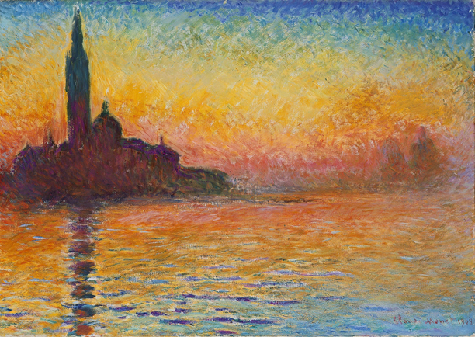
Fig. 1. Claude Monet, San Giorgio Maggiore at Dusk, 1908–1912.

Lorem ipsum dolor sit amet, consectetur adipiscing elit. In nec risus pretium, condimentum leo imperdiet, iaculis lacus. Curabitur volutpat sagittis facilisis.
Works Cited
Adams, Amanda. Citing Sources: How to Cite a Book. Academic Press, 2019.
Barnes, Barney. “A Chapter in an Edited Collection.” A Book of Examples, edited by John Smith, Academic Press, 2019, pp. 25–35.
Cox, Christopher, and Brian D. Smith. “The Title of the Article.” Website Name, 15 Sept. 2019, www.scribbr.com/page.
Dayton, Daniels, and Bob Matthew Williams. “Journal Article Title.” Journal of Academic Research, vol. 32, no. 15, 2014, pp. 232–265, https://doi.org/10.1080/02626667.2018.1560449.
Fox, Ferdinant, et al. The Basics of Citing in MLA Style. 2nd ed., Scribbr Press, 2008.

How to Easily Create MLA Citations
Create your own MLA style citations with the free Scribbr MLA Citation Generator. It’s the easiest and most reliable tool for creating and managing your MLA Works Cited list and in-text citations, based on the most recent 9th edition MLA format requirements.

